_____________________________________________________________________________________
___________________________________________________________________

Directions for WGA Demos and Exhibition

Directions toWGA Demonstrations and the Annual WGA Exhibition!
At the First Baptist Church, 3 Winn St./Park Street entrance, Woburn Center
Free Parking is only in the rear for the above.

From Rt. 95/128 take either the Winn St. exit #34, or the Main St. exit #35, south, or
From Rt. 93 take the Montvale Ave exit #36 toward Woburn. See further below.

If taking Main Street, go about 1.5 to 2 miles to, just entering Woburn Center. Take your immediate first right, before Winn Street onto Park Street. You will see a red brick building on your left, which is the First Baptist. Entrance and parking is in their rear lot.

If taking Winn Street, go to the end of Winn Street (road ends), go around the center past City Hall and bear left again in front of Citizens Bank. Stay straight but bear slightly to the right. That immediate right is Main Street! Winn Street will be on your left, but Park Street will be slightly to the right. You will see a red brick building on your left, which is the First Baptist. Entrance and parking is in their rear lot.

If taking Rt. 93, take the Montvale Ave exit #36 toward Woburn, about 2.5 miles to Woburn Center (road ends). take that right at the lights. Stay straight but bear slightly to the right. That immediate right is Main Street! Winn Street will be on your left, but Park Street will be slightly to the right. You will see a red brick building on your left, which is the First Baptist Church. Entrance and parking is in their rear lot.

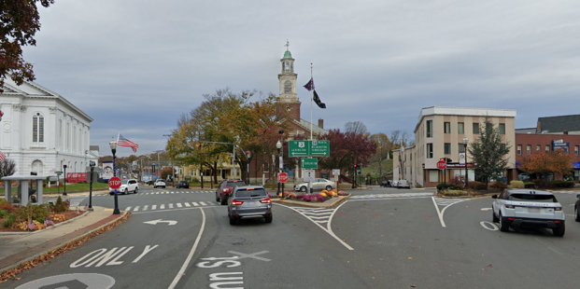

Winn Street - Park Street – Main Street

____________________________________________________________________

